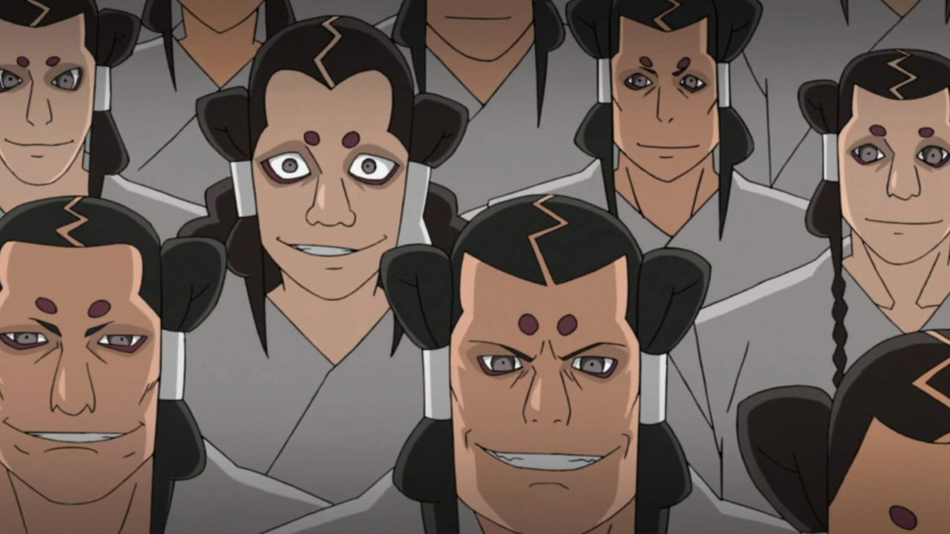  
Kaguya Clan  
  
  
  
The Kaguya Clan (かぐや一族, *Kaguya Ichizoku)* Is a clan known for their savagery in battle, archaic values, and inability to be reasoned with. Their ways make them more akin to wild animals then humans in the eyes of outlaying houses. They believe that a glorious death will earn them higher status and power in the next death, and all they glory they earned in the world of the living will be returned ten-fold in the world of death. They reside in Watashitachi, Wa Tsuiho.  
  
  
  
  
  
  
  
  
  
History  
  
**Preface**

The Kaguya clan was born of the one called the **Pygmy Kaguya**, said to have been a female that feasted upon the flesh of both powerful men and beast. As she practiced this, she gained abilities similar to those she had slain and consumed. Each time her body and mind grew more primal and moved from instinct rather than intuition. She soon awakened a dormant power to manipulate her skeletal structure that is now seen in Kaguya Clansman closely related to her lineage. She began to have offspring and rule a large lay of land, though her true name was forgotten in time. She was widely renown for her ivory white hair, a trait that was inherited by her children. Due to dilation   
  
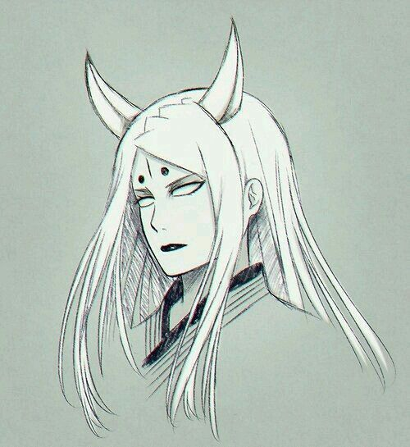 **Pygmy Kaguya (Age 31)  
  
  
Current**

The Kaguya clan had been a threat for quite some time before the Don’Yoku turned their attention to them. They soon found that they could not barter with the Kaguya in any fashion, they would often capture and torture their messengers with no reason other then entertainment. They struck fear into the hearts of many men, but not the Don’Yoku. Soon after they began to hunt down the clan, placing a bounty upon their head for all to claim. The clan began to lose members rapidly and soon after went into hiding. Sometime during their hiding, they had been discovered by the Uchiha who took them in. The Kaguya joined forces with the Uchiha and Hoshigaki before founding *Watashitachi, Wa Tsuiho*. They currently have a bounty of 7,500 Ryo above their head.

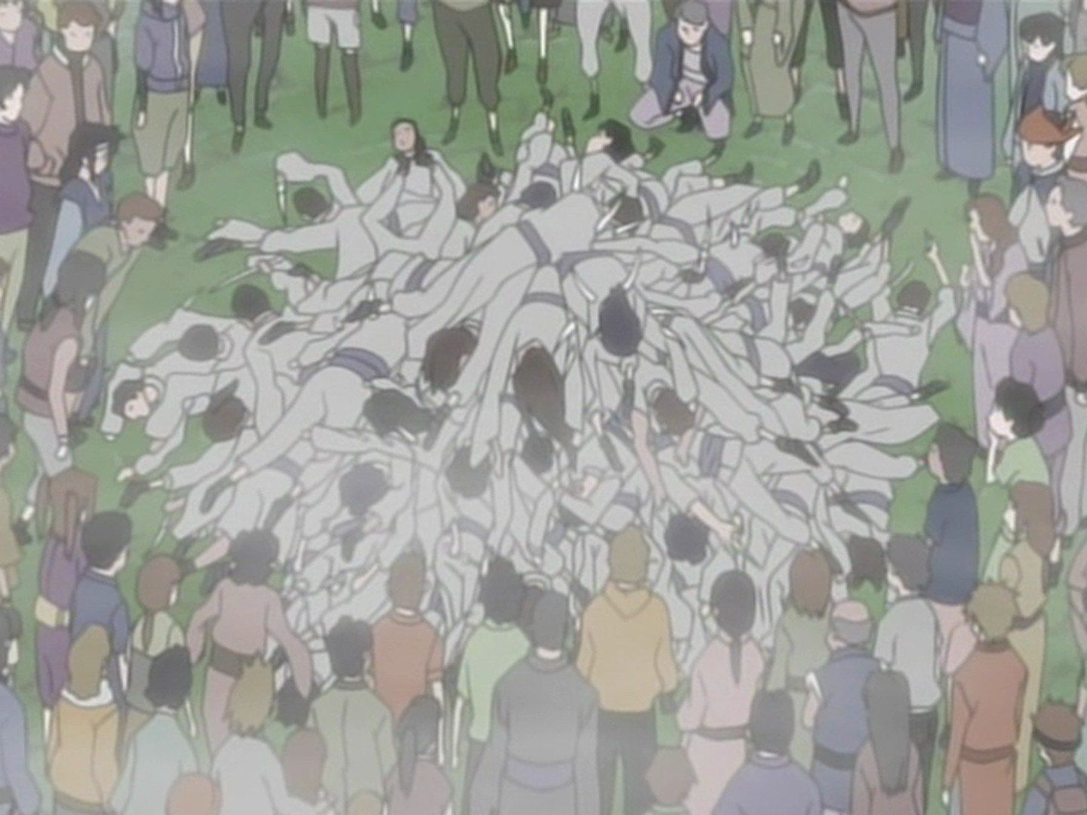

***Great Kaguya Massacre at the hands of the Don’Yoku***  
  
Description

Kaguya’s trademark is the two crimson dots upon their forehead. Their hair color pallet goes from light brown to black, rarely it can be seen to be white after developing their Kekki Genki **Shikotsumyaku** *(屍骨脈, Dead Bone Pulse).* They often have their names end with -Maru.  
  
Kaguya tend to have more violent tendencies, and do not fear death in battle. It is virtually impossible to reason with Kaguya, and if they want to do something they are beyond stubborn. They respect the strong and those for their strength solely.  
  
  
  
  
  
  
Player Guide  
 *Kaguya are known to be quite violent, they revel in both combat as well as committing heinous acts towards their enemy. They have a fierce hatred of cowardice and take absolute pride in themselves and their fighting ability. With this being said they a fiercely loyal to their kin and those they live with, though they show love in a more obtuse way such tyrannizing in a playful manner. They do not get their feelings (or bodies) hurt easily and are a relatively rough bunch.*  
  
  
  
  
- White hair is exclusive to those who have Shikotsumyaku, and is tied with being a direct ancestor to the Pygmy Kaguya. Their hair can be anything from Brown to grey, but never white. All Kaguya have the red dot markings on their forehead and will never hide them no matter what.  
  
- Kaguya do not show their fear of combat, not to say they have none. This does not mean they will wildly accept any challenge or attempt to fight with any odds against them. They are human and have reasoning, but are extremely stubborn when they want to do something.  
  
- Kaguya are one of the few clans who can kill without having a strict reason to, although they still cannot kill on first encounter. They tend not to kill those who put up good fights as it excites them.  
  
-Kaguya’s have a basic grammar school education, knowing basic Math, Science, English. They have very little education further then this.  
  
-Kaguya’s diet consist of mostly meat with few vegetables, and alcohol. They are known to drink and partake in adult activities at very young ages.  
  
-Kaguya will rather partake in direct combat then using espionage and trap, and have no knowledge of setting up traps. They rarely use Ninja Tools, although they have the ability to.  
  
-The Kaguya often refer to the Pygmy Kaguya, using the name *“The Primal One”* or *“The White Beast”* rather then any god or deity. Praising them for kills or what they refer to has “Harvests”. Commonly praying for “A Good Harvest”.

-Kaguya usually have names ending with -Maru, and often will be referred to with a Maru at the end of their name by other Kaguya even if it isn’t their actual name. It is very uncommon to not have the ending in their name but not impossible if born from one parent outside of the clan.